WSU Team Gleason Overview
  - Dave Bakken, 25 September 2013

Contents
Executive Summary 1
Senior Project AY13-14 2
Broader Efforts 2
Future Senior Projects in Collaboration with Other Majors 2
Team Gleason in New Orleans 2
WSU Team Gleason Club 2
Open Source Movement for ALS 3
Home Monitoring 3
The Initial Team 3
How you can help 4
Contact Info 4
Team Picture 5

Executive Summary
Former WSU football star and New Orleans Saints special teams cult hero Steve Gleason has ALS, a debilitating and cruel disease that strips its victims of the ability to control their muscles and kills them in 2-5 years. However, until the very end patients can control their eyes and eyelids. This is the primary way they communicate – by blinking – after their voice goes.
The equipment for this is crude, for example it does not do predictive typing like any smart phone does when it guesses the rest of your work from a few letters. It is also very expensive, $4K to start with a barebones system and often way more (Steve’s system costs $20K). This is far beyond what Medicare will cover and what many victims of ALS can afford to pay themselves, so sadly they simply can’t communicate effectively once their voice is gone.
WSU’s “World Class, Face to Face” students and faculty will develop inexpensive technology and release it under open source license with no royalties in order to disrupt this unacceptable status quo for ALS patients. This will start with a senior project during this school year but there are broader plans. Steve Gleason and his bravery, his mother Gail, and Team Gleason are well known to many WSU students so we anticipate no problem in getting broader involvement from students from many majors over the next year and beyond.

Senior Project AY13-14
The first part of this movement will be a yearlong computer science senior project this school year, in the School of Electrical Engineering and Computer Science (EECS). The project will use Android predictive typing software, whose source code is available free of charge and is stable and well documented.
The tasks this first year of senior project is developing much better software using 3 different hardware platforms:
- A generic Android tablet computer,
- TheEyeTribe hardware for better eye tracking accuracy, running on Windows 8 on a Microsoft Surface Pro Tablet,
- The Pupil system that is like wearing glasses but where a commodity webcam tracks eye movement.
- The Tobii system with a Windows 8 tablet TBD. This is tentative, depending on progress and if we can add another student 499 project in the spring.
Initial useable prototypes of all 3 (or 4 with Tobii) will be completed by April 2014. We anticipate it would be 6-12 months after that until real ALS patients (outside of a few beta testers in Pullman) could use it.
The project will also investigate the integration of the eye tracking systems we develop with a motorized wheelchair. This would give ALS patients an affordable option to use the wheelchair after their hand and arm muscles don’t allow them to use its joystick. We do not expect a full implementation this school year, but a preliminary investigation and initial design so that prototyping work could begin in Fall 2014. We also may begin support for iPad then (we are avoiding it at first because it is a closed ecosystem and there is no compelling reason to use it to start with such as there is with Win8 to use TheEyeTribe hardware.)

Broader Efforts
As mentioned above, the senior project this year is just one of a number of ways in which WSU will help ALS patients. Prof. David Bakken (WSU ’85) will help to start these efforts.

Future Senior Projects in Collaboration with Other Majors
There will be one or more senior projects in future years helping move this technology forward. We hope to get other departments involved, for example Computer Engineering (digital hardware), Mechanical Engineering (for more analog hardware and devices such as actuators and motors), business (market analysis), and others.

Team Gleason in New Orleans
All efforts described here will coordinate closely with Team Gleason, which is headquartered in New Orleans. They are well aware of this project, and the WSU team has already interacted with its chief technologist, ALS patient Eric Valor (who can now only communicate by blinking) via email and videoconference.

WSU Team Gleason Club
A WSU Team Gleason student club will be formed. This will allow students from majors outside of EECS to be involved. But, crucially, it will also allow EECS students to get involved well before their senior year. This will help a lot on development issues, but also provide much more long-term continuity and institutional memory than if the development efforts were a new crop of seniors each year who work for a school year then are done.
Getting WSU club status won’t be possible until August 2014. However, until then the club will - be hosted in EECS. Governance will be set up for approving purchases from the club’s funds.
Caveat: we can’t start anything on getting this project going until January. We simply have too much to do between then and now.

Open Source Movement for ALS
All software implementations and hardware designs will be released open source and free for others to use. The team also plans on starting an international open source community around this, most likely starting some time in 2015.
While the technology from WSU will be free, a company may charge for the systems they build with the WSU technology. None of the WSU professors or students plan to make any money off of this, but letting others do so is crucial to enable the technology to be widely available and thus have the broadest possible impact. We also anticipate that systems will be available, especially in the first few years, from Team Gleason, possibly at no charge above the hardware costs (or even free), and/or possibly by other non-profit organizations.

Home Monitoring
Prof. Diane Cook is a computer scientist whose expertise includes artificial intelligence and machine learning. She heads the CASAS smart home project. CASAS is a world leader in monitoring elderly patients to learn patterns and determine when they need help. This has received huge funding from NIH, NSF, and others, because it can help keep elderly patients out of assisted living for months or even years, which is a huge cost savings. So far the CASAS lab has developed learning profiles for Alzheimers and Parkinsons patients, and it hopes to add ALS patients in the next year or two once a research grant is secured.

The Initial Team
The team is excited about how much they can help ALS patients, and profoundly thankful for the opportunity. They are also ecstatic about the likelihood of the recognition that their beloved WSU will garner through this movement.
All 3 seniors on the core senior project team are huge Cougar football fans, as is Prof. Bakken and of course Gail. The present team members are:
- Prof. David Bakken (WSU ’85) a computer science professor who co-supervises the senior project and will spearhead the efforts to broaden the movement from beyond just the first year senior project. He is originally from the Seattle area and worked at Boeing from 1985-1988.
- Prof. Sakire Arslan Ay, who co-supervises the senior project (and supervises all others)
- Gail Gleason, a long-time friend of David and his wife and a learning specialists who tutors and counsels WSU football players and who is completing a doctorate in education. Gail comes to all the meetings and who has been a mother lode of practical information on ALS patients limitations as well as having many useful contacts
- Adam Thompson, a member of the senior project team from Maple Valley.
- Forest clay, a member of the senior project team from Vancouver.
- Peter Cramer, a member of the senior project team from Seattle.
- Andrew Lytle, a computer engineering junior from Kent who is doing an independent study (499) class to help the team
- Calin Scott, a computer science 5th year senior from Colbert who has already done his senior project but is doing an independent study (499) class to help the team.

How you can help
Senior projects in EECS are normally funded by donations from industry. Companies typically pay $10K for hardware and software as well as travel to the company. They also provide a mentor who is an expert in the area of the senior project. Companies do this not only for altruistic reasons but to get access to students whom they may hire.
This senior project has no corporate sponsor so it needs funds. Initially, it needs $5K for hardware and software (the two professors supervising this have paid almost $1K of their own money to jumpstart the project, but this can’t continue).
Beyond this, there is another opportunity beyond the $5K. The 3 seniors plus Prof. Bakken tried to meet Steve at GleasonFest in Spokane this August. They arrived at 10am, but Steve was having a bad day, as Gail updated them throughout the day, so at 4pm they gave up and went back to Pullman where they had other commitments. While missing a chance to meet Steve and learn up close about his limitations and technology was disappointing, the team learned a huge lesson in Steve’s almost complete inability to control his body or his schedule. This has doubled their resolve to make a difference to ALS patients.
Thus, if sufficient funding arrives, the 3 seniors, Prof. Bakken, and Gail hope to visit Gleason House in New Orleans and talk at length with Steve and ALS patients in the house. This would be the Monday and Tuesday before Thanksgiving and would cost approx. $10K.
Additional money would cover other club expenses such as pizza, which is standard for such club meetings (because it greatly helps boost student attendance, especially for new student checking out a club). There are longer term possibilities, too, beyond the above, and any additional funds will be used for future endeavors approved by the club’s leadership. One concrete possibility here is to hire a student programmer in Summer 2014 to help move the software base forward so that the AY14-15 senior project team can be even more productive and the first public release can be earlier. And if the movement grows large enough, then hiring a student part time to help with communications, outreach, and otherwise offloading the core people working on the technology would be extremely beneficial.
To donate, click here. In the notes field on that page, PLEASE put how you heard of this: through CougFan.com, a WSU event, word of mouth, a NOLA newspaper, the Saints, etc.

Contact Info
Email to teamgleason@eecs.wsu.edu will go to Professors Bakken and Arslan Ay (and eventually others in a leadership position).
(5O9) 592-O238 is Prof. Bakken’s mobile phone (but please use email if at all possible). Caveat: here we used a letter ‘O’ not number ‘0’ to possibly avoid web crawlers.
Prof. Bakken will be in Seattle about 1pm on Saturday if anyone wanted to meet to discuss this. He could also come earlier Saturday or even possibly Friday night.

Team Picture
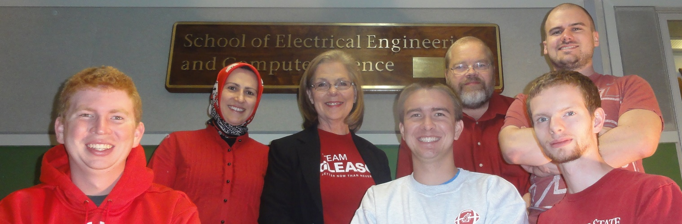
Back row: Sakir Aslan Ay, Gail Gleason, Dave Bakken, Forest Clay
Front Row: Peter Cramer, Adam Thompson, Andrew Lytle
Not pictured: Calin Scott
Taken after our weekly meeting on Friday, September 20, 2013

