EE334 Computer Architecture Name: _________________________________

Homework Assignment 7 April 4, 2012

Problem 1
A branch is within a loop has the following repeating pattern (i.e. branch outcomes): T, NT, T, T, NT
- What is the accuracy of always-not-taken branch predictor?

- What is the accuracy of the two-bit predictor (shown below) for the first five branches in this pattern, assuming the predictor starts off in the bottom left state 00 (predict not taken)?
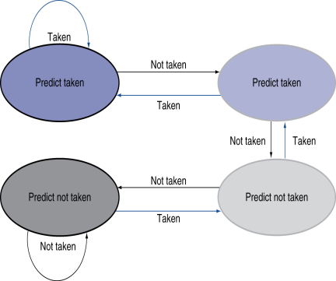
The table below may be useful to calculate the accuracy.
10

01
11

00
Prediction | 0 (NT)
Actual Branch outcome | T | NT | T | T | NT
Right(1)/Wrong(0) Pred. | 0
New Prediction | 1 (NT)

- What is the accuracy if this patter is repeated “forever”? (In the table below please begin with the last prediction from (b)

Prediction
Actual Branch | T | NT | T | T | NT | T | NT | T | T | NT | T | NT | T | T | NT
Right/Wrong
New Prediction

Problem 2
A benchmark in a five-stage pipelined processor that uses a branch target buffer has the following characteristics:
31% ALU instructions,
26% Load instructions (assume no hazards with loads for this problem)
14% Store instructions
21% Branch instructions (62% of these branches are taken).
8% Jump instructions

A branch target buffer for conditional branch and jump instructions has the following features. Branch and jump instructions are found in the buffer (hit rate) 89% of the time. 92% of the time the prediction of the buffer is right (accuracy); thus, there is no penalty. Addresses for both branch and jump instructions are known at the end of the ID stage.

Please determine the CPI (cycles per instruction) for this machine.
Hint. Consider penalties/stalls due to:
- BTB misprediction (when a branch is found in BTB but its prediction is wrong) and
- BTB miss (when branch/jump is not found in BTB and is taken).

